**EAS Ambulatory Cognitive Assessments Codebook—SAS Version 1**

05/25/2017—02/26/2020

**Cognitive Test:** **Dot Memory**

Test for spatial working memory (2 trials per session).

**Reference:**

1. Sliwinski, M. J., Mogle, J. A., Hyun, J., Munoz, E., Smyth, J. M., & Lipton, R. B. (2018). Reliability and validity of ambulatory cognitive assessments. *Assessment, 25(1),* 14-30.
2. Siedlecki, K. L. (2007). Investigating the structure and age invariance of episodic memory across the adult lifespan. *Psychology & Aging, 22(2),* 251–268.

**Instruction:**

(a) The participants are asked to remember the location of three red dots. (b) After grid is removed, participants are required to touch Fs among Es for 8 seconds. (c) Empty 5 × 5 grid reappeared on the screen and participants are prompted to recall the location of initial three dots.

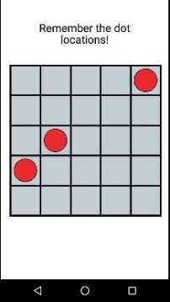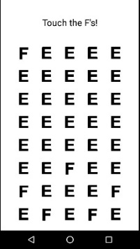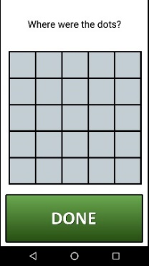

**Outcome Variables and Interpretation:**

|  |  |  |  |
| --- | --- | --- | --- |
| **SAS Var. Name** | **Var. Level** | **Interpretation** | **Response Scale/Note** |
| error | Trial | error is the sum of the Euclidean distances for all 3 responses. So a 0 means they got all 3 correct. Higher score means worse spatial working memory. | Euclidean distance error score |
| Response_time | Trial | Response time at trial level. Higher score means worse spatial working memory. |  |
| spat_dmn | Session | Mean of error |  |
| spat_dsum | Session | Sum of error |  |
| spat_dsd | Session | Std of error |  |
| rt_mn | Session | Mean of response time |  |
| rt_med | Session | Median of response time |  |
| rt_std | Session | Std of response time |  |
| memory_qual | Session | Quality control—check the correct trial numbers | 1= correct number of trials;  0=incorrect number of trials. |

**Cognitive Test:** **Symbol Search (Symbol Match)**

Test for processing speed/visual attention (11 trials per session).

**Reference:**

Sliwinski, M. J., Mogle, J. A., Hyun, J., Munoz, E., Smyth, J. M., & Lipton, R. B. (2018). Reliability and validity of ambulatory cognitive assessments. *Assessment, 25(1),* 14-30.

Deary, I.J., Johnson, W., & Starr, J.M. (2010). Are processing speed tasks biomarkers of cognitive aging? *Psychology and Aging, 25(1),* 219-228.

**Instruction:**

Participants are asked to decide which of the two pairs at the bottom of the screen was among the pairs at the top of the screen as quickly as possible.

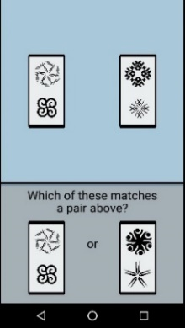

**Outcome Variables and Interpretation:**

|  |  |  |  |
| --- | --- | --- | --- |
| **SAS Var. Name** | **Var. Level** | **Interpretation** | **Response Scale/Note** |
| Response_time | Trial | Response time at trial level –higher score means worse visual attention. | millisecond |
| symrt_mn | Session | Mean of response time |  |
| symrt_med | Session | Median of response time |  |
| symrt_sd | Session | Std of response time |  |
| symbol_qual | Session | Quality control—check the correct trial numbers | 1= correct number of trials;  0=incorrect number of trials. |

**Cognitive Test:** **Color Dot**

Test for working memory precision (4 trials per session).

**Reference:**

Liang, Y., Pertzov, Y., Nicholas, J.M., Henley, S.M.D., Crutch, S., Woodward, F., Leung, K., Fox, N.C., & Husain, M. (2016). Visual short-term memory binding deficit in familial Alzheimer's disease. Cortex, 78, 150-164.

**Instruction:** (a) 3 colored dots appear briefly on the screen at first. Participants are asked to try to remember the location of these colored dots. (b) Colored dots disappear. (c) Participants are asked to recall the location of these colored dots on the screen by 1) selecting the correct color of the dot at a certain location; 2) moving one colored dot to its original location.

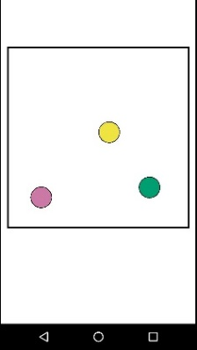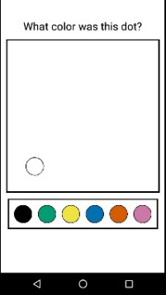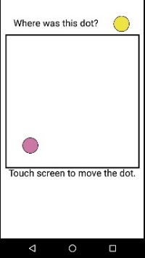

**Outcome Variables and Interpretation:**

|  |  |  |  |
| --- | --- | --- | --- |
| **SAS Var. Name** | **Var. Level** | **Interpretation** | **Response Scale/Note** |
| colorAnswer | trial | Precision of the color selection | 1=correct color;  2=wrong color, binding error;  3=wrong color, random error. |
| locAnswer | trial | Precision of the location selection | 1=correct location;  2=wrong location, swap error;  3=wrong location, random error. |
| color_doc_acc | session | Color Dot Color Precision |  |
| color_swap | session | Color Dot Color Swap Errors |  |
| color_random | session | Color Dot Color Random Errors |  |
| dist_acc | session | Color Dot Dist Precision |  |
| dist_swap | session | Color Dot Dist Swap Errors |  |
| dist_random | session | Color Dot Dist Random Errors |  |
| color_doc_quality | session | Quality control—check the correct trial numbers | 1= correct number of trials;  0=incorrect number of trials. |

**Cognitive Test:** **Color Shape Binding**

Test for short-term memory binding (5 trials per session)

**References:**

1. Parra, M. A., Abrahams, S., Logie, R. H., Mendez, L. G., Lopera. F., & Sala, S. D*.* (2010). Visual short-term memory binding deficits in familial Alzheimer’s disease. *Brain,* 133,2702–2713.
2. Parra, M. A., Abrahams, S., Logie, R. H. & Sala, S. D. (2010). Visual short-term memory binding in Alzheimer’s disease and depression. *Journal of Neurology, 257,* 1160–1169.

**Instruction:**

(a) Colored shapes appear briefly on the screen. Participants are asked to try to remember the shapes and their colors. (b) Colored shapes disappear. (c) Next screen shows the same shapes and participant are asked whether the shapes have the SAME or DIFFERENT colors as they have before.

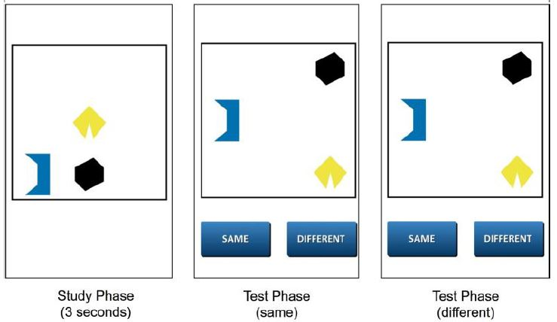

**Outcome Variables and Interpretation:**

|  |  |  |  |
| --- | --- | --- | --- |
| **SAS Var. Name** | **Var. Level** | **Interpretation** | **Response Scale/Note** |
| cs_hit | trial | Hit | 1=yes, 0=no |
| cs_fa | trial | False alarm | 1=yes, 0=no |
| cs_miss | trial | Miss | 1=yes, 0=no |
| cs_crej | trial | Correct reject | 1=yes, 0=no |
| cs_pr | session | =hit percentage-false alarm percent |  |
| cs_br | session | =false alarm percent/(1-cs_pr) |  |
| color_shape_qual | session | Quality control—check the correct trial numbers | 1= correct number of trials;  0=incorrect number of trials. |